360digitalsignage Enterprise

User Manual

This document, ©2010, 360digitalsignage.Com., is designed for the sole use of our clients and no portion of it may be copied, published, or otherwise distributed to parties outside the agreement outlined herein without the express written permission of 360digitalsignage.Com.

Contents
1 Manual History 3
2 Login 4
3 System Administration 5
3.1 New User Account 5
3.2 Delete User Account 5
3.3 Change Password 6
3.4 Create New Role 7
3.5 Parameter dictionary 8
3.5.1 Create Screen Resolution 8
3.5.2 Resource Category 9
3.5.3 Component Config 10
3.5.4 Edit Approval 11
3.5.5 Data Collection Service 13
4 Resources 14
4.1 Video 14
4.2 Image, Music, Text, Flash 16
4.3 Template 16
5 Content Managements 18
5.1 Create New Contents 18
5.1.1 Image 20
5.1.2 Text 21
5.1.3 Scroll Text 21
5.1.4 Flash 22
5.2 Delete Contents 23
5.3 Schedule and Publish Contents 24
5.3.1 Schedule 24
5.4 Delete Content from Players 30
6 Player Monitoring 33
6.1 Player Information 33
6.2 Player Monitoring 34
6.3 Caption 35
6.4 Bandwidth 36
6.5 Meeting Room Management 36

Manual History

Manual Revision | 360digitalsignage Version | Publication Date
C | 1.0 | July 2009
D | 3.0 | July 2010
E | 3.1. | Sep 2010
F | 3.1.5 | Feb 2011
G | 4.1 | Aug 2012

Login
To launch 360digitalsignage software, click Digital Signage icon 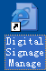 on your computer desktop. If you are logging from the computer other than the server, launch Internet Explorer and type url http://serverIP/webedit
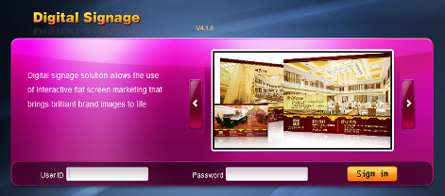
There is a pre-define Admin account “sa”. The default password is 123456. After you sign in the system, you can change the password for this account.

System Administration

New User Account
To create a new user account, click Admin →User→New. Enter User ID and Name. And then choose an organization and assign appropriate roles. When you have done, click Submit.
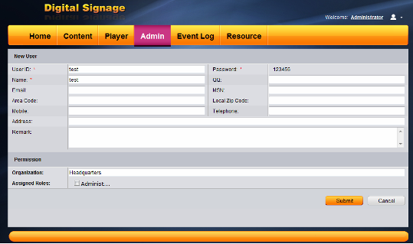

Delete User Account
To delete a user account, click Admin →User→Select User→Click Delete
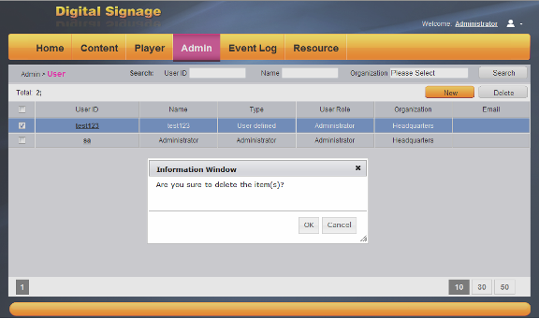

Change Password
To change password for a user, login with the User ID, then click change Pwd
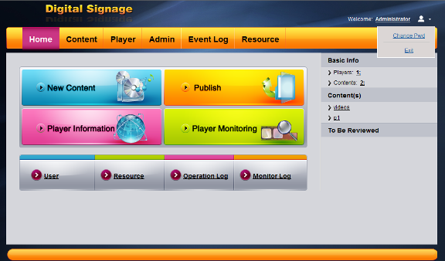
You need to enter the old password, new password and confirm password. And then click Ok.
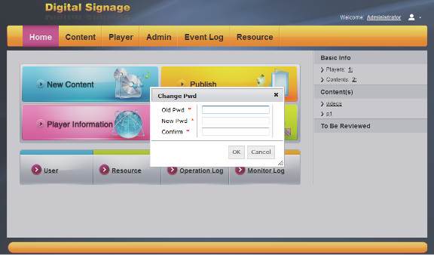

Create New Role
Click Admin →Role→ New, Enter name, apply level and then choose the permission for the role. Click submit
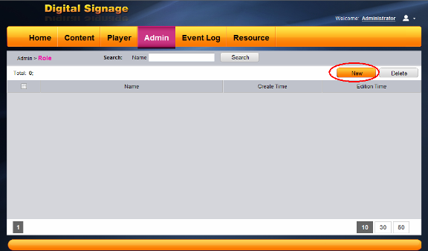
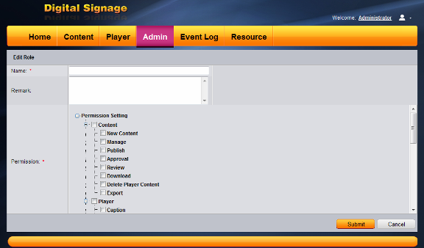

Parameter dictionary

Create Screen Resolution
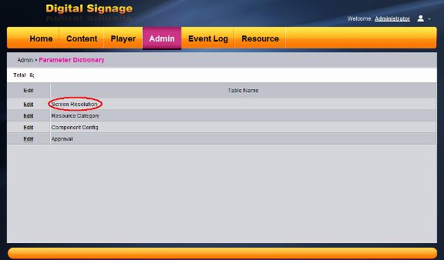
Click Edit→New→Enter Width and Height →Save. If you click add, you can continue to add new resolutions
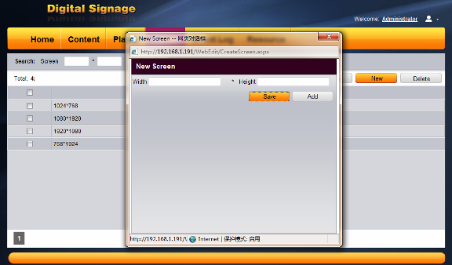

Resource Category
Click edit→New→Enter new folder name and select classification→ Save
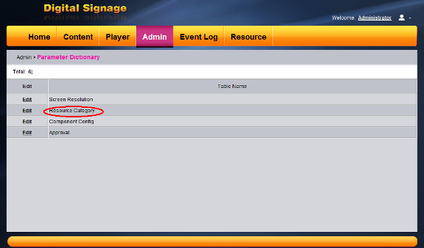

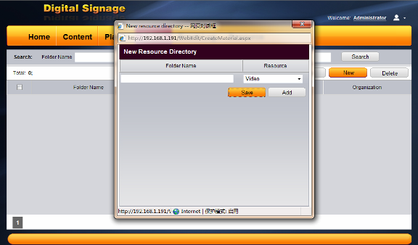

Component Config
Click edit→Config→Select the components→Save
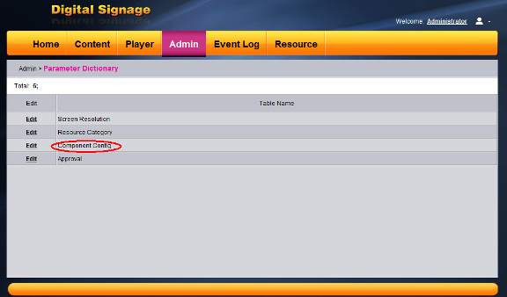

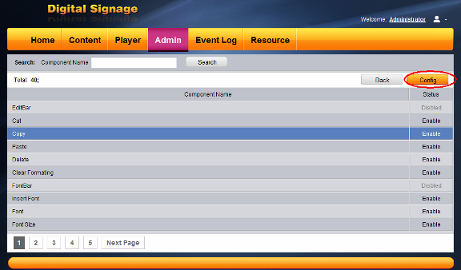
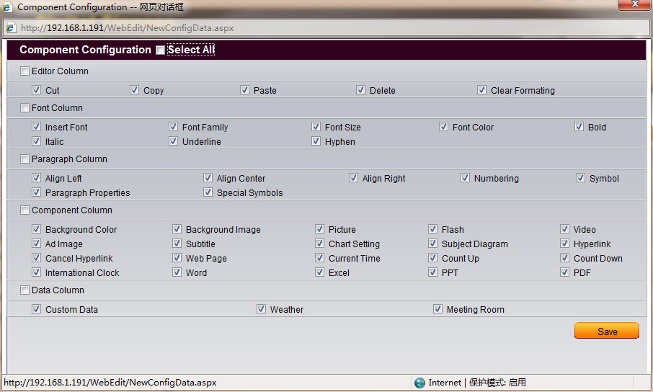

Edit Approval
Click Edit→Edit→Choose the approval type (default type is Level one approval)→Save
You can choose Level one approval、Level two approval and No approval required.
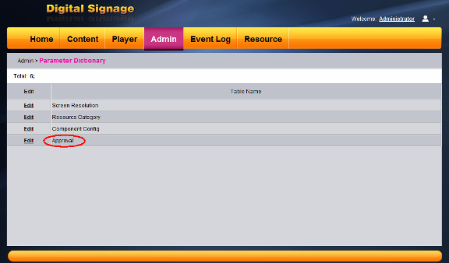
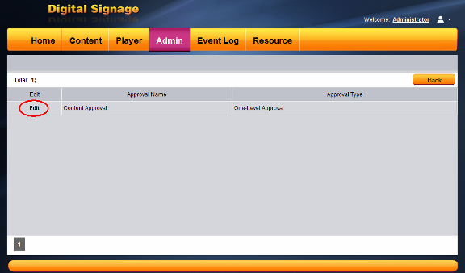
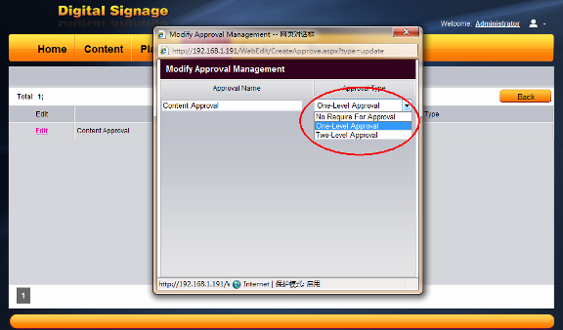

Data Collection Service
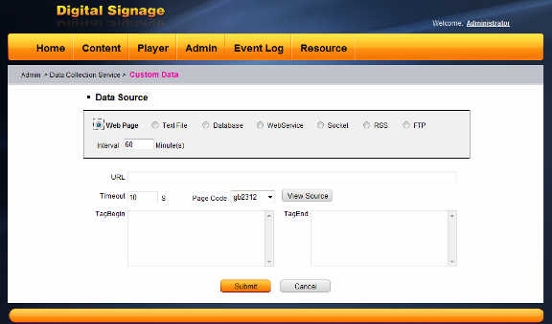
If you have any real time data want to show in the content, you could use the customer Data Service.

Resources
Resource menus are used to maintain Video, Image, Music, Template Flash, PDF, and Word, Excel, PowerPoint files. The Template menu is used to maintain predefined templates and user templates.

Video
To maintain video files, click Resources → Video. You can upload or delete video from system.
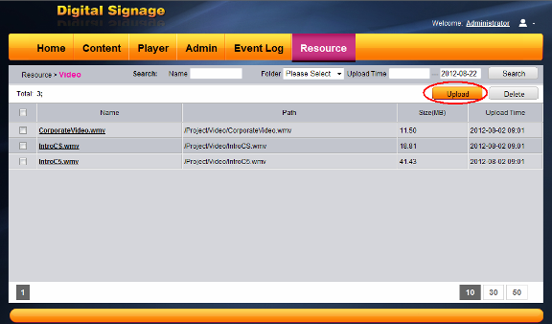
To upload a video, click . Navigate to the directory where your video file is located. Select the file and then click open. If you want to upload multiple files, press the shift or ctrl key and mouse left button to select files and then click open. And then click
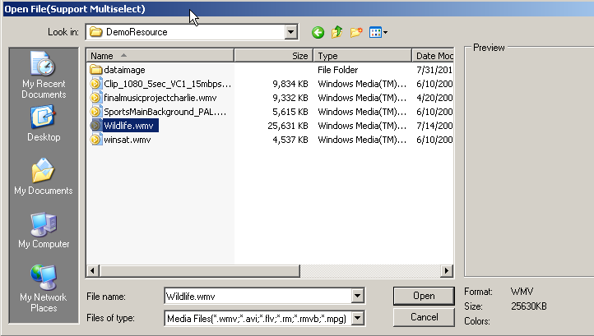
To delete a video file, select the video file and then click Delete.
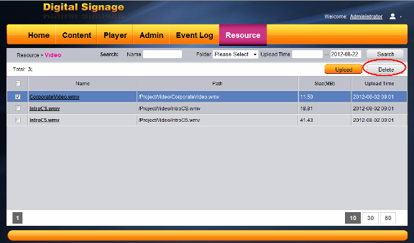.
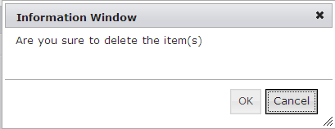
Then click OK. The file will be deleted.
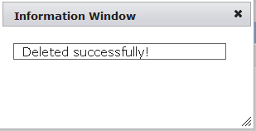

Image, Music, Text, Flash
Follow the same steps as video files to maintain image, music, text and flash files. The text file means Microsoft Word, Excel and PowerPoint.

Template
You can create your own templates for future use. To create a new template, click Resources → Template → New
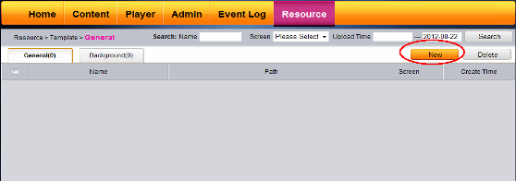
Enter template name and resolution, After you complete the design, click .
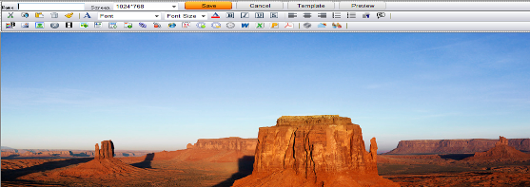

Content Managements

Create New Contents
To create content, click New Content
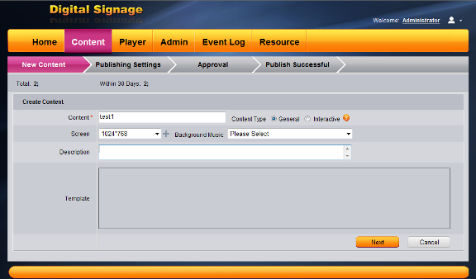
Enter content name and select screen resolution. Then click Next . The system will take you to Content Design Studio.
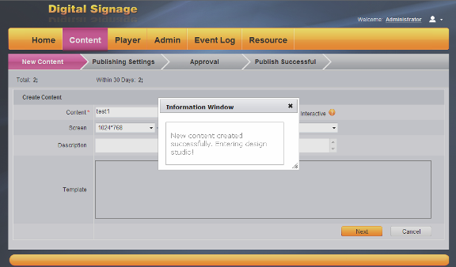
The Page Name and Play Time (how long the scene will be played) are required for a scene. Enter the name for the scene and time it will play (in seconds). Then you can start your content design.
To find out the function of an icon, move the mouse pointer on top of the icon. The following lists are some of the icons.
- This function supports touch screen. You can use the link to create
Customer interactive scene
- Used to edit text on selected area
- Font color
- Set background color
- Load background image
- Load Image to a selected zone
- Load Adobe Flash to a selected zone
- Load video to a selected zone
- Load multiple images to a selected zone. You can set the
time interval to display each image
- Create scroll text
- Insert Table
- Insert web page
- Count up
- Count down
- International clock
- Display current date and time
- Display PowerPoint on the selected zone
- Display Excel on the selected zone
- Display Word on the selected zone
- Insert custom data
- Insert meeting information

Image
To add an image to the scene, click image icon.
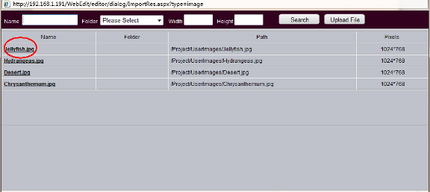
Select an image from the list, e.g. Jellyfish.jpg. Double click the name. Use your mouse to resize and move to the location your desired. Then click anywhere on the screen to release your selection.

Text
To add text, click icon, a text edit area will display on the screen
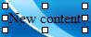
Move the text area to any location of your choice and resize the text area. Then double click on New Content to start text edition. You can set the color, font size. The following is an example of text area.
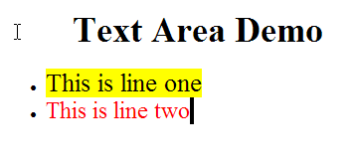
Font selection
Font size
Bold, Italic and underline
Font color and highlight
Alignment
Numbering and Bullet
Decrease Indent and Increase Indent
When you have done, deselect the text area by click anywhere on the screen.

Scroll Text
To add scroll text, click
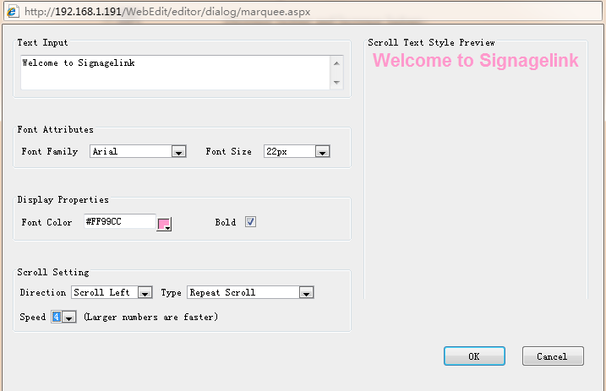
You can choose the font and set the font size and color. You can also adjust the scroll text speed and type. Then click OK. Use the mouse to select the scroll text you just created, resize and move to your desired location.

Flash
To add adobe flash, click
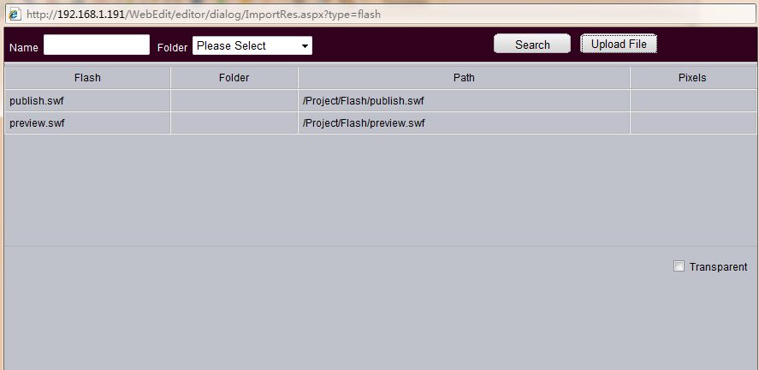
Select a flash from the list, and then click OK. Use the mouse to select the flash you just created, resize and move to your desired location.
You can follow the steps above for other features. After you complete your scene design, click to save the design. To add another scene, click , and then follow the steps above to create more scenes. You can preview your design by clicking . After you have completed your design, you can publish the content.
To publish the content directly, click
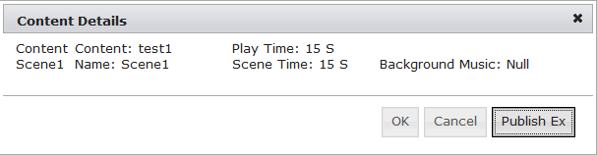
If you click, OK, the content will be saved. If you click , then it will go to publish screen.

Delete Contents
To delete a content, click Manage. Select the content you want to delete. And then click delete.
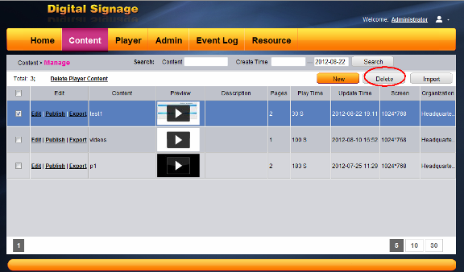
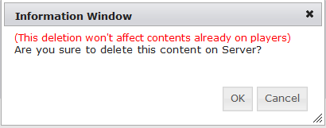
Click OK to confirm content deletion.

Schedule and Publish Contents

Schedule
After you finish your content design and click , the system will automatically load content schedule screen. You can also navigate to this screen by click Publish.
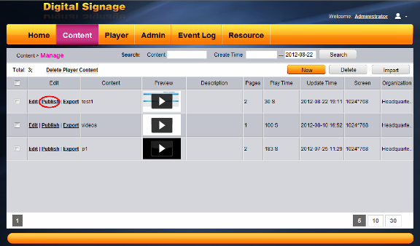
After click publish, it goes publishing settings.
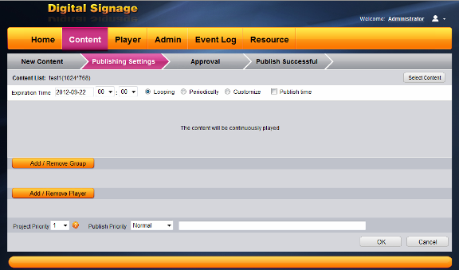
You must set content expiration time.
Select means that “The content will be continuously played in expiration time”.
Select means that “The content will play by weekly or monthly”
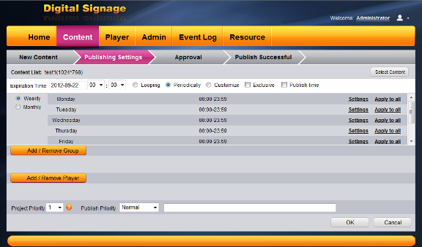
Select means that you can set the start date and end date; start time and end time as you like.
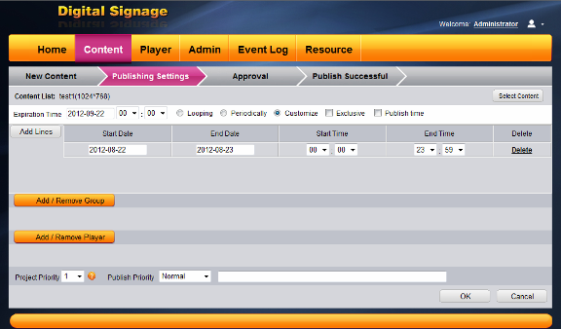
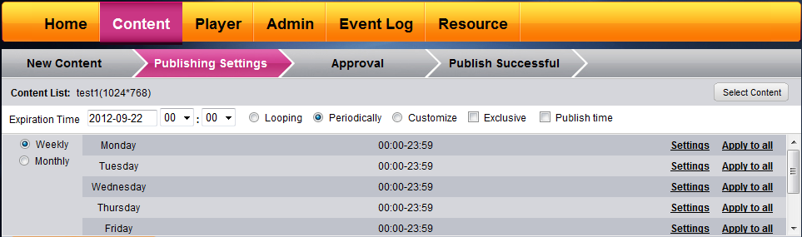
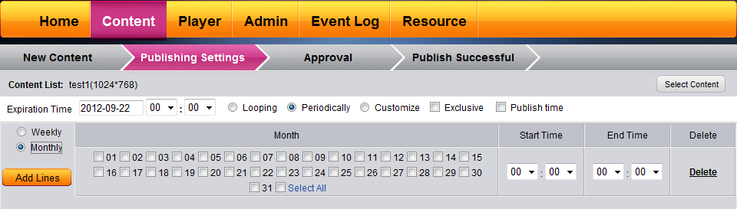
If you check , it means this content has priority to be played at the time you set.
If you check , you can set the publish time in advance.
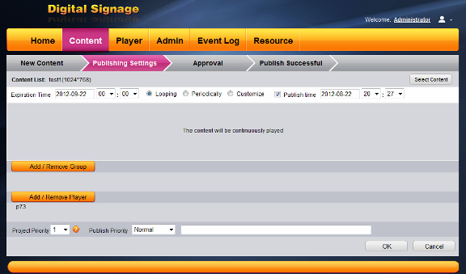
After you have finished the setting, add the player(s), click button.
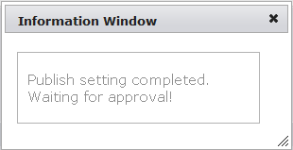
Then it goes to the approval page.
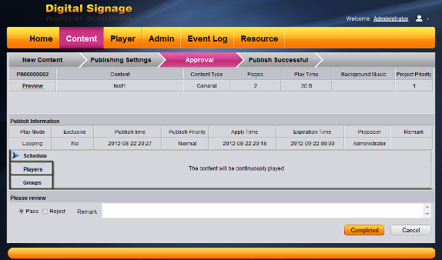
Select or , If you select reject, you should add remark.
Select , then click .
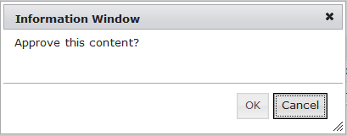
Then click ok.
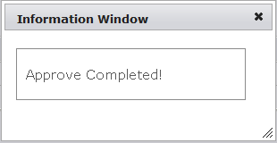

The following screen shows the sample content played.
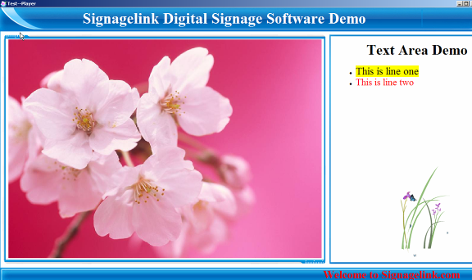

Delete Content from Players

There are two ways to delete the content.
One . To delete a content from players, click Player→Player information→ Click Player Name
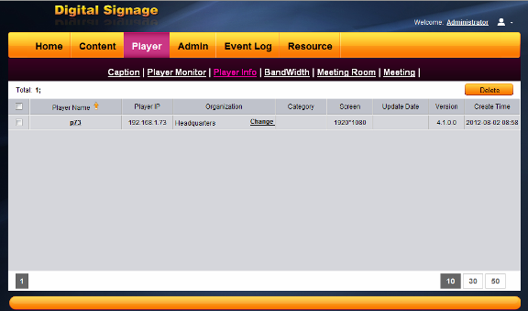
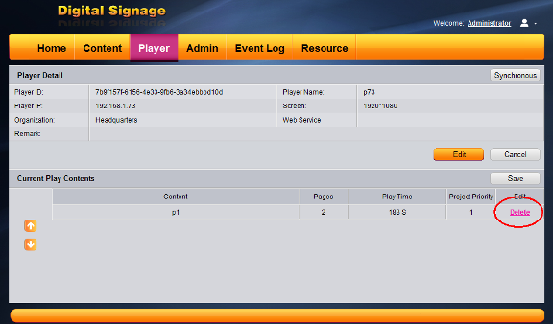

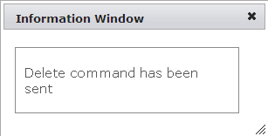
Check the content you would like to delete, and then click Delete.

Two. Click Content→Delete Player Content→Select the content you want to delete→click Delete
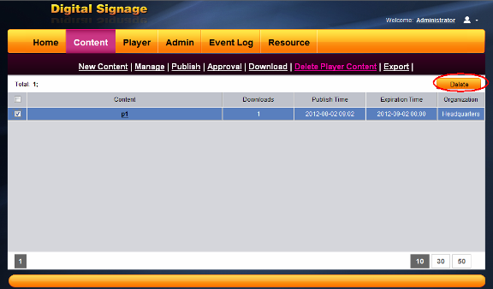
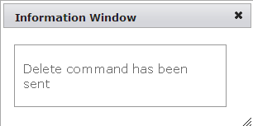

Player Monitoring

Player Information
To view player information, click player→player information
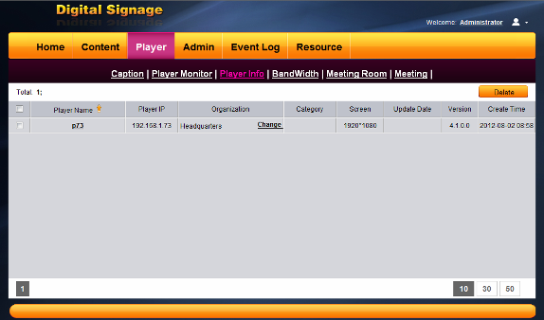

You can see player information such as screen resolution, IP address, player Name and so on. If you want to delete a player from the list, check 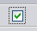 the player you would like to delete, then click .

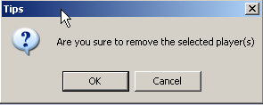

Click OK to confirm the action.

Player Monitoring

To monitor player, click player→player Monitor.
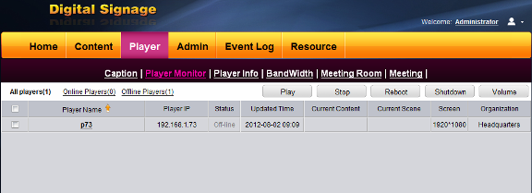

The screen shows the information about players. To view detailed information, click the link under Player Name, e.g. P73.

If you want to look the current content of a player, you can click .Wait for about 60sec, you can see the screen at the right corner.
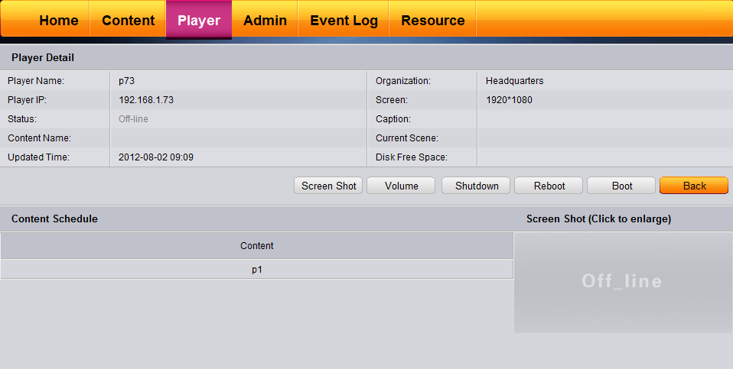

If you want to reboot the player computer, click
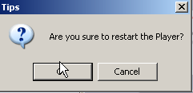

Then confirm the restart. To shut down the player, click
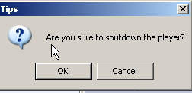

Then confirm the shutdown.

Caption
This function allows you to insert the message.The
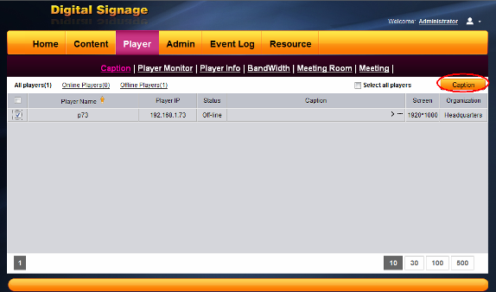
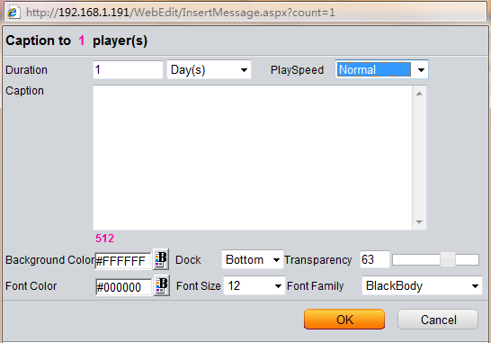

Bandwidth
This function allows you to control the bandwidth of the player.

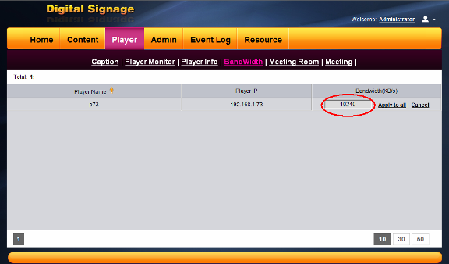

Meeting Room Management
Step 1: Create a new meeting room and name the meeting room and choose the player for the meeting.

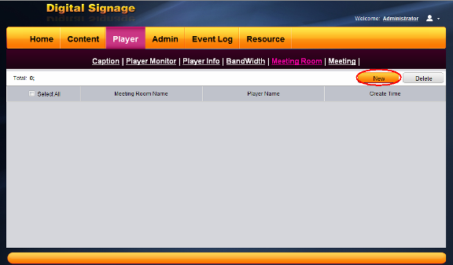
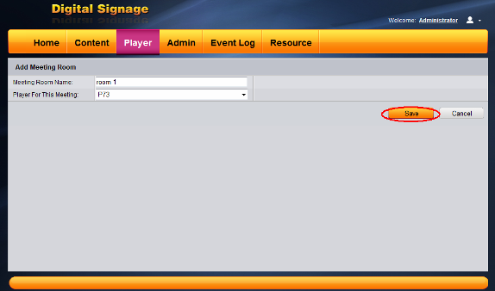
Step 2: Create a new meeting, choose a meeting room, name it and set the start time, end time and host company.

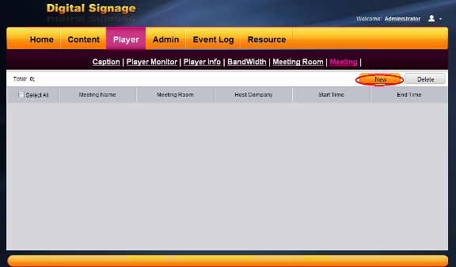

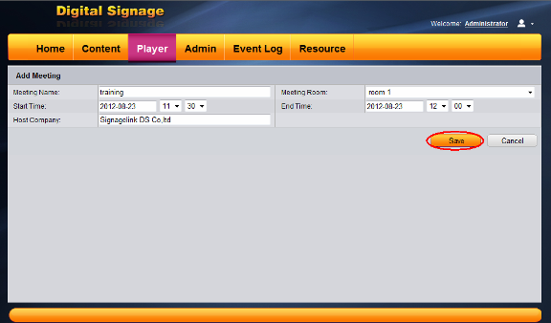

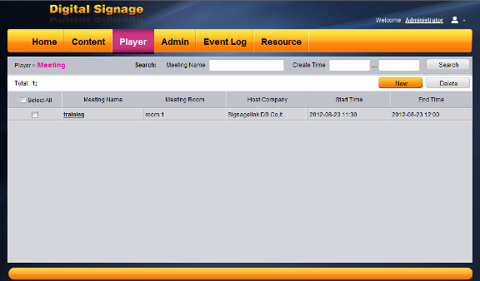

Step 3: Go to Data Collection Service→Meeting Room →Setting. Choose Data Source as Database; fill in the refresh time.
Type: MySQL, Server: localhost,
User ID: root, Password: empty
Database: webedit, Datatable: eb_meeting.
Then Click
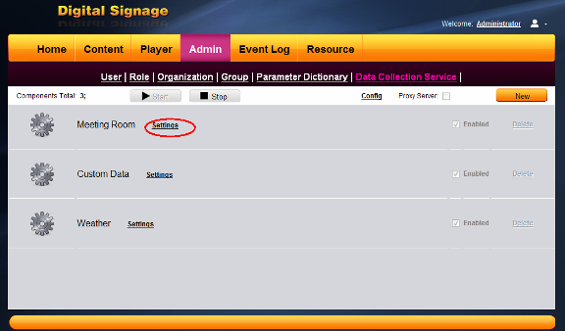

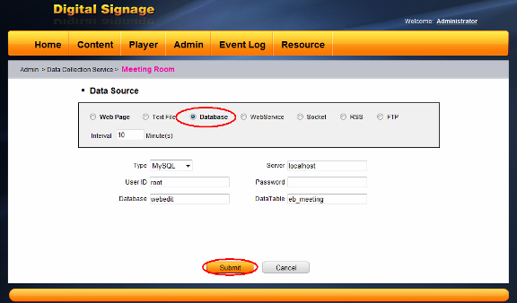

Step 4: Choose the information you want to show. Then save it.
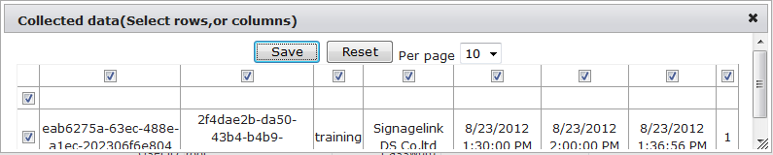
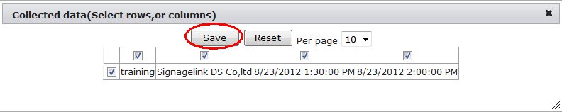

Step 5: Go to New content. Name the scene and set the play time and click the meeting room icon.
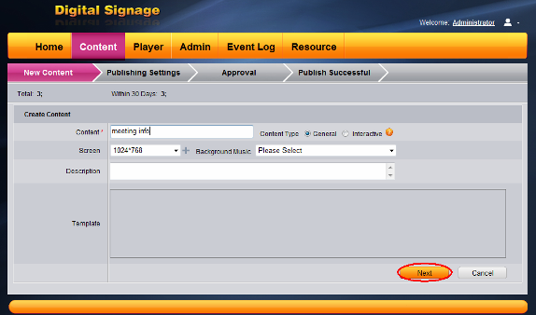

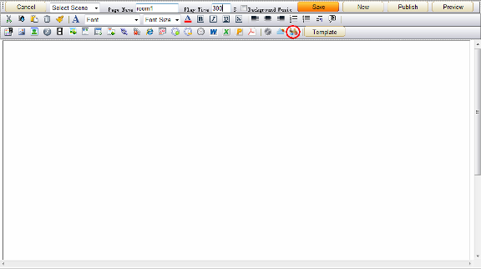
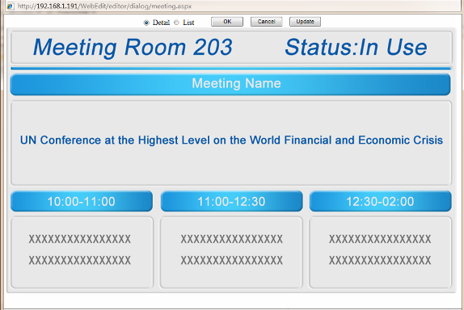

Detail shows the meeting information of each meeting room.
List shows all the meeting information of all the meeting rooms.
Click update and ok. Save the content and publish it to the player. After approve it, the meeting information will play.

Note: The content making and publishing process only need to be done once. If you have new meeting, you could create the meeting as follows:
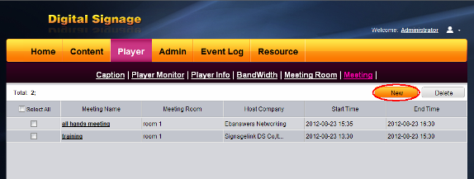

END

